Twenty-ninth Sunday in Ordinary Time (Year C)  Reading I: Ex 17: 8-13  Responsorial Psalm 121: 1-2, 3-4, 5-6, 7-8  Reading II: 2 Timothy 3: 14 – 4: 2  Gospel: Luke 18: 1 - 8  Readings may be found on the US Bishop’s website:  https://bible.usccb.org/bible/readings/101622.cfm | 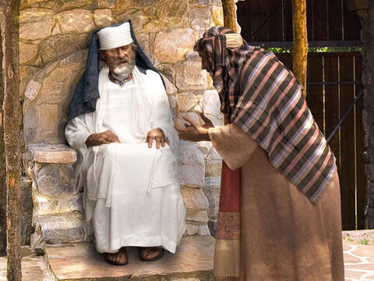  Unjust Judge, copyright, FreeBibleImages
Jesus offers a parable about perseverance in prayer. It falls in the midst of other teachings about prayer. An important context comes before the verses that we have today. At the end of the previous chapter, a Pharisee asks Jesus "when the kingdom of God would come." Jesus responds that "the kingdom of God is among you." Luke's audience has suffered persecution and may be wondering when God's reign will begin because many had thought Jesus would have returned by this time.
Jesus offers the parable to encourage them to persevere in prayer. The judge offers no hope for justice for the widow. So for many people, there seems to be no justice for the suffering that they are experiencing. Jesus assures them that God is not deaf as the unjust judge. God will respond to the needs of those who call out to God and bring forth justice. The question is whether people will remain committed and wait for God's action. Human hearts can grow tired and give up hope. Disciples must not demand a response on their timeline. The disciple knows that God is faithful and will respond. Perseverance in prayer is essential.
Injustice can seem overwhelming in our society. There is prejudice, deceit, abuse, and fraud in every direction that one looks. With great effort, a community can address a particular issue, but the other dozen continue to grow. It can make a person weary and tempted to give up and just take care of her/himself. Disciples must stay open to speaking the truth, experiencing rejection, and working against great odds. Jesus laid down his life for the many. So too, disciples are called to carry on that mission of Jesus even when the obstacles seem enormous.
Prayer is the one source of strength and hope. Prayer is not about how many words are said. Prayer is a deepening of friendship and intimacy with God. It is a deep and intimate conversation with God that helps each person come to know God's mind and heart. In these conversations, one develops one’s identity as a daughter or son of God. This enables one to continue the mission of Jesus in bringing forth the reign of God in each person's life.
The first reading from the Book of Exodus offers an example of perseverance. After having left Egypt, the Israelites encountered many sufferings and disappointments. They asked in various ways, “Is God with us?” God provided manna and quail to eat, water from the rock to drink, and guided them through the desert. Now they are faced with Amalek in battle. These were seminomadic people from the southern part of the Holy Land and into the wilderness of the Negev. Fearing the approach of the Israelites, they sought to defend their territory. Moses is confident that God is with them and is guiding them. Moses goes up the hill to pray with arms outstretched over the battle. Moses is aware that it is not the Israelites’ efforts but the work of God that will bring victory. Moses grows tired during the battle and needs assistance. Aaron and Hur must help support his arms. Victory comes to the Israelites through the persistent prayer of Moses, assisted by others. This is an important lesson for each person. God is the one who brings results, and often it requires the assistance of others to remain strong and focused.
Timothy is reminded to be faithful to what he has learned and integrated into his life. The reliability of the Sacred Scriptures is affirmed. It is dependable because God inspired it. The Church believes that God used humans to write the scriptures. Their knowledge and cultural setting limited them. God worked through them to convey who God is and what God asks of humans. The author’s knowledge of history, geography, science, and nature is limited by their time and culture. Even with these limits, God revealed who God is and the work of salvation to the human family. Thus the scriptures are beneficial for teaching, training, and correction. Everyone is called to faithful and persistent in bringing forth the reign of God in their time and place.

Reflection Questions:
What are some of the ways in which you pray?
What role does Scripture have in forming your attitudes and actions?
Who has supported you in your life of prayer?
How are you helping to bring forth God's reign in your life and this culture?

Themes:
Prayer, petitionary and conversational
Biblical Inspiration
Perseverance in Prayer
Patience and Hope

Prayer Suggestions:
For the Church: that we may be persistent in prayer and attentive to God’s invitations to greater discipleship
For fidelity: that God will sustain us as we encounter challenges and keep us faithful to the virtues of the Gospel in our decisions and actions
For a greater love of the Scriptures: that our hearts may desire to hear and learn God’s Word and be open to the wisdom it offers
For all who support us in our journey of faith; for family, friends, and fellow believers: that God will renew and strengthen each of us so that the work of God may be more evident in the world
For all who are growing weary in seeking justice and for all who are working to assist them: that the Holy Spirit will give them strength and help them to persevere

© Joseph Milner, 2022

